Title: CarParts Monitoring SOP

Purpose:

The purpose of this SOP is to establish a standardized daily process for monitoring all orders placed through the CarParts sales channel to ensure:

Orders are successfully received and acknowledged

Orders are processed and transmitted to suppliers or fulfilled from stock

No orders are missed, delayed, duplicated, or stuck in the system

Shipping timelines are met according to company standards

Profitability and operational accuracy are maintained

This SOP ensures real-time visibility, accountability, and timely issue resolution for all CarParts orders to prevent late shipments, supplier delays, and customer dissatisfaction.

Scope
This SOP applies to all CarParts orders received daily through Go-Parts systems, including:
- New orders
- Backorders
- Cancelled orders
- Duplicate orders
- Orders pending supplier confirmation
- Orders pending tracking upload
- Late shipment risks
The scope includes:
- Reviewing CarParts orders in Central / order management system
- Cross-checking supplier portal (if applicable)
- Confirming order transmission
- Monitoring fulfillment status
- Escalating issues to Operations, Purchasing, or Tech when necessary
- Updating tracking and shipment status
This process is performed daily (hourly monitoring preferred during business hours) to ensure operational accuracy and prevent service disruptions.

Responsibilities

Operations Team

Monitor CarParts order feed daily

Verify orders are properly received in Central

Confirm supplier transmission (CP, Keystone, etc. if applicable)

Check for stuck, unprocessed, or failed transmissions

Monitor late shipment risks

Follow up with suppliers when no confirmation is received

Escalate technical issues to IT (e.g., Mohit) if orders are not transmitting

Ensure tracking numbers are uploaded once available
Purchasing Team
- Ensure orders are placed accurately with correct supplier
- Confirm buy price, availability, and shipping method
- Monitor backorders and advise Operations if delays are expected
Operations Manager / Supervisor
- Oversee monitoring compliance
- Review late shipment trends
- Identify recurring issues (system, supplier, or process gaps)
- Ensure SOP adherence and updates when needed

Procedure Steps:
CP MONITORING
1. ) CP Monitoring – Checking all orders for the day (B2B Orders 2025), then transferring the daily data to the “CP - JAN 2026” sheet.
B2B All Order(s) 2025
2.) then transferring the daily data to the “CP - FEB 2026” sheet.
CP - Feb 2026
3.] Checking for tracking details for every PO
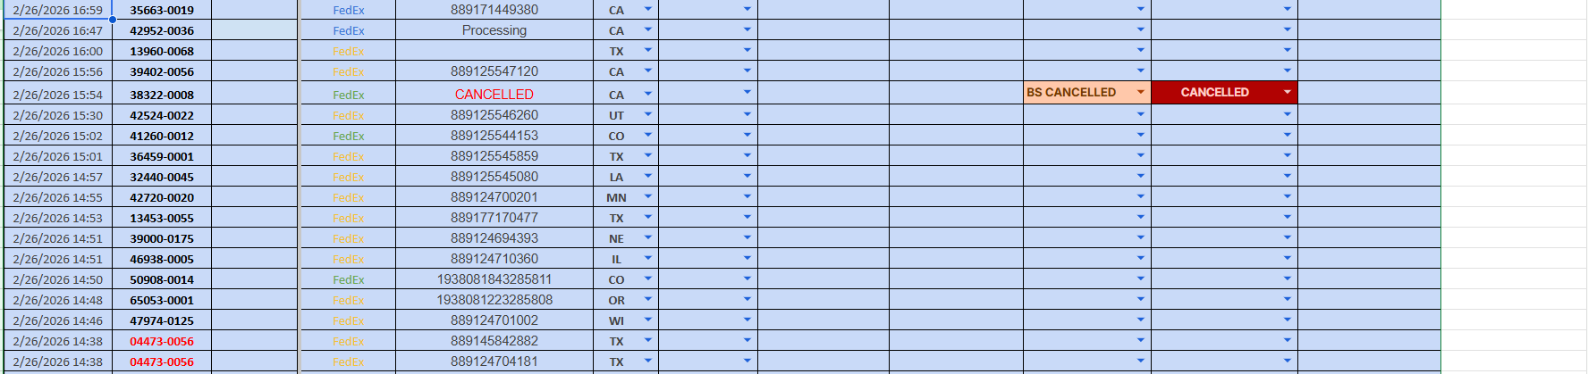
4.) Go to Central and Search for the PO number.
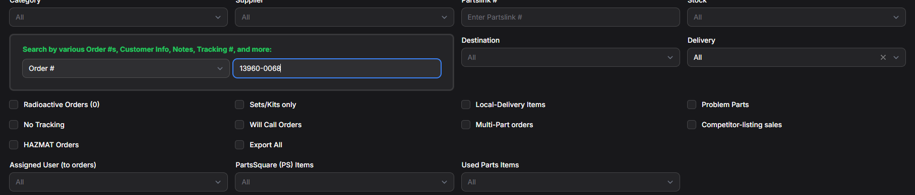
5.) Click the FedEx tracking details.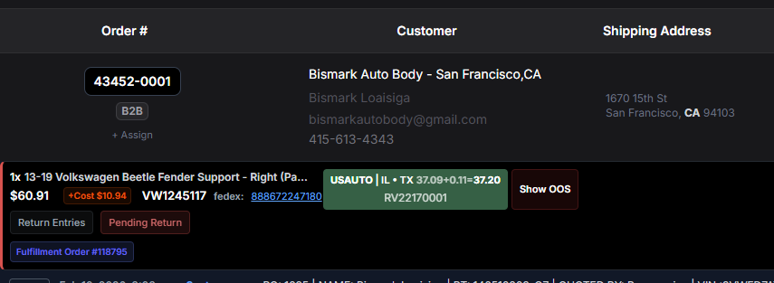
6. Transfer the tracking information to the daily “CP - FEB 2026” sheet.
CP - Feb 2026
7. ) Monitor and check the daily movement/status of each PO’s multiple tracking details on FedEx Website. 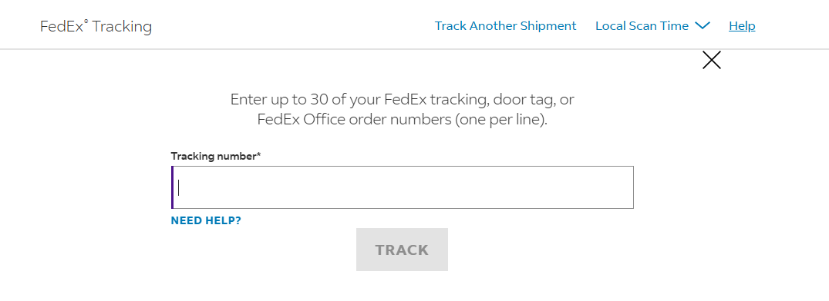
8.) If the tracking status remains “Label Created” with no movement, notify the B2B Representatives.
9. ) Will email the Carparts for the Label Created. After 2 days will follow up Carparts and after the ETA is reach, will offer the customer Replacement or Refund for the Possible Lost in Transit.

