Core Charge — New Workflow & Operations Guide
Audience: Operations team
Applies to: Central admin → Orders (the order Items row)
Last updated: June 2, 2026

1. Why we changed this
Core charges never had a real process. Until now, everything about a core charge lived in
order notes — when the supplier waived it, when we refunded the customer, what the return
label cost, the tracking number. That created real problems:
- Information gets lost. Notes are free text. They get buried, overwritten, or never written
at all. There was no reliable record of what happened with a core.
- Costs were confusing. The return label cost for the part and the **return label cost for
the core** are two different things, and they were easy to mix up. There was no clean place to
separate them.
- No single source of truth. To answer "did the supplier charge us? did we refund the
customer? what did the core return cost?" you had to read through the whole notes thread.
This is a broader issue than just adding a button — we never had a structured way to track
anything related to core charges.

2. What's new
A dedicated Core Charge workflow with its own badge/button on each item that carries a
core charge. It records the entire core-charge story in one structured record per item:
- Waived core charge — the supplier does not charge us the core, and we give the customer
a refund.
- Returned & Refunded — the customer returns the core, we refund them, and we record the
return label cost and tracking # for the future.
- Supplier credits for a core return are recorded automatically, as usual — no manual
entry needed.

3. The benefits
- One source of truth. Everything about a core charge lives in one place on the item — no
more digging through notes.
- Nothing gets lost. Structured fields instead of free-text notes; the record shows who
updated it and when.
- Clear cost separation. The core's return label cost is recorded separately from the
part's costs, so the two never get confused again.
- Clean numbers for reporting. Amounts are validated as positive values, so core-charge money
flows correctly into reporting.
- Faster and consistent. Ops follows the same simple steps every time.

4. Where to find it
On the Orders list, open the order and look at the item. The Core Charge button sits
right next to Return Entries, and only appears on items that actually carry a core charge.
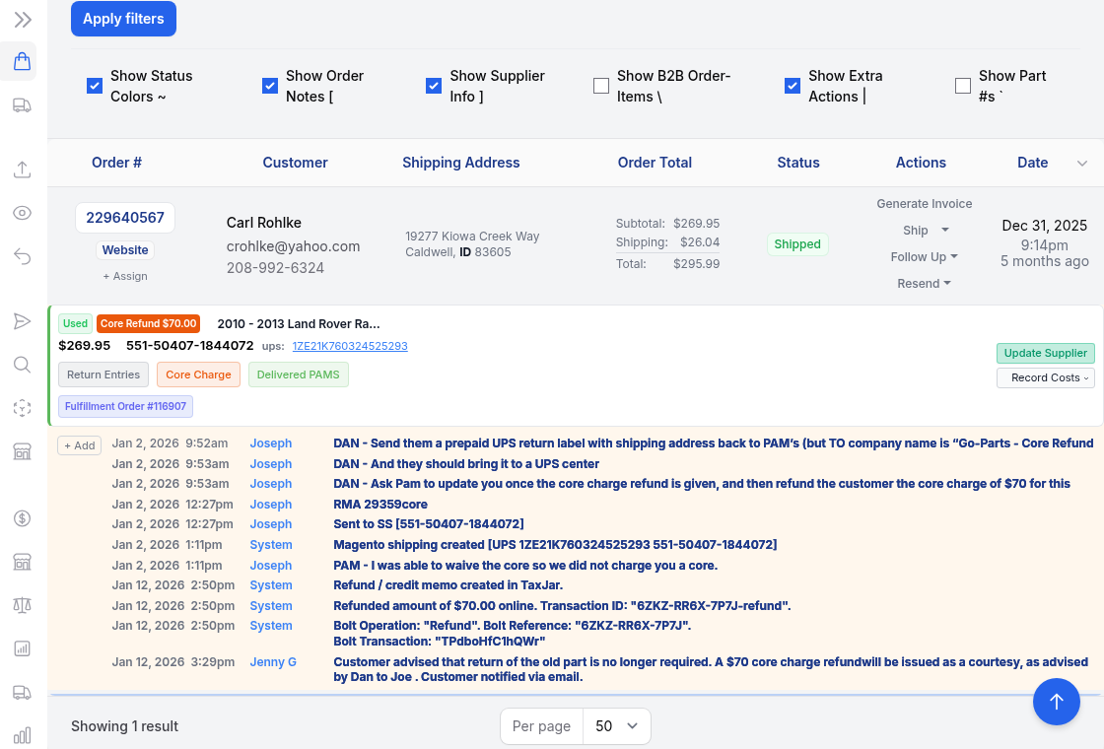
*(Example: order 229640567 — note the Core Refund $70.00 badge and the orange Core Charge
button. The notes on the right are the old way of tracking this; going forward it lives in the
Core Charge record instead.)*
Click Core Charge to open the recording window. There is one record per item — re-opening
it edits the same record, so there are never duplicates.

5. The two cases — pick the one that matches what happened
Case (Status) | When to use it | What you record
Waived | The supplier waived the core — we were not charged. We refund the customer immediately, with no return. | Customer Refund Amount only
Refunded | The customer returns the core. We refund the customer and send the core back to the supplier. | Customer Refund Amount, Return Label Cost, Return Tracking # for Core

The window shows or hides fields automatically based on the case you choose.

6. Case A — Waived (supplier waived the core)
Use this when the supplier did not charge us for the core, so there is nothing to return —
we simply refund the customer.
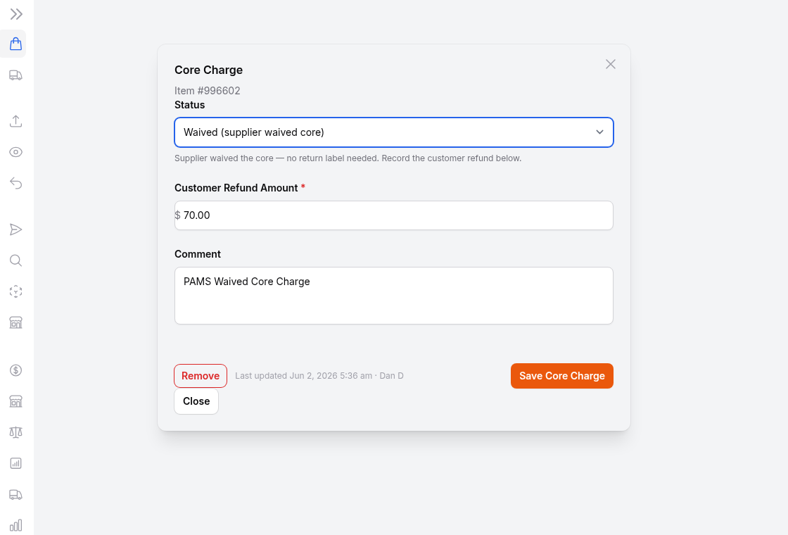
Steps:
- Open Core Charge on the item and set Status = Waived (supplier waived core).
- Enter the Customer Refund Amount — the core refund given to the customer (required).
- Comment (optional) — e.g. "Supplier waived core charge".
- Click Save Core Charge.
No return label, tracking, or label cost is needed — those fields are hidden for a waived core.
Real example — order 229640567: The supplier (PAM's) waived the core
("*I was able to waive the core so we did not charge you a core*") and the customer was
refunded $70.00. That is recorded as Status = Waived, Customer Refund Amount = $70.00,
as shown above.

7. Case B — Returned & Refunded (customer returns the core)
Use this when the customer is sending the old core back and we return it to the supplier.
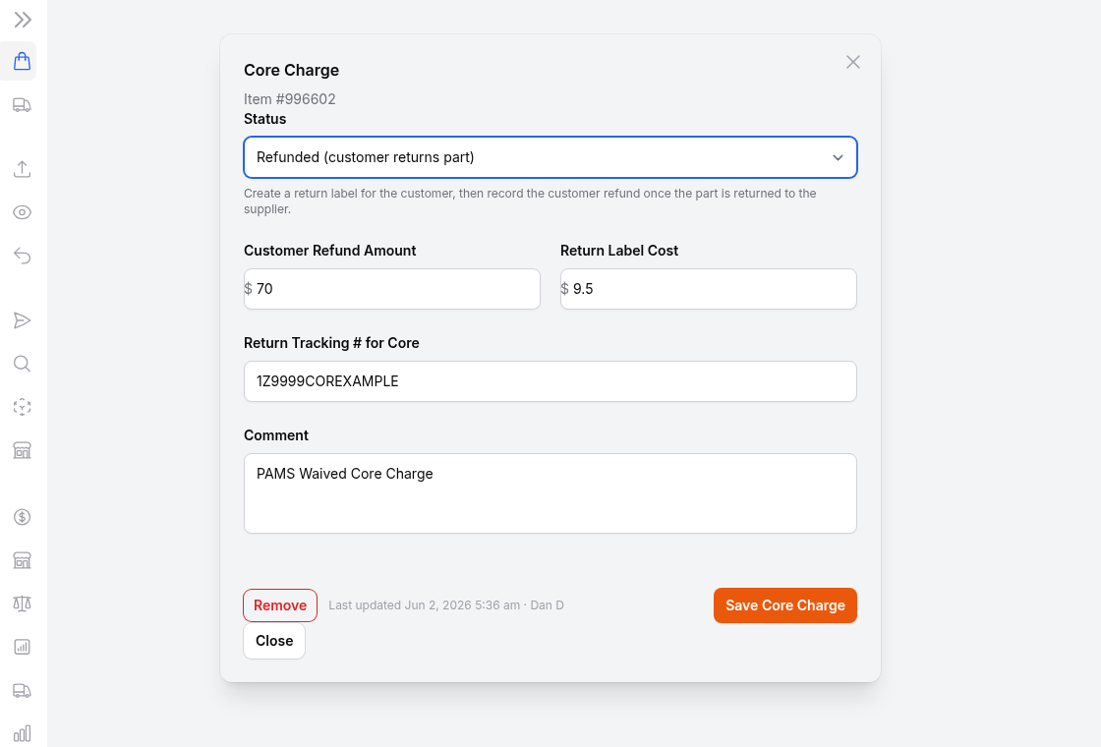
Steps:
- Open Core Charge on the item and set Status = Refunded (customer returns part).
- Create the return label for the customer as usual.
- Fill in:
- Customer Refund Amount — what the customer gets back for the core.
- Return Label Cost — what the core return label cost us (this is the core's label,
kept separate from the part's label cost).
- Return Tracking # for Core — the tracking number for the core going back to the supplier.
- Comment (optional) — RMA #, etc.
- Click Save Core Charge.
You can save in stages. Record the tracking # and label cost when you create the label, then
re-open the same record later and add the Customer Refund Amount once the core is back with
the supplier and the refund is issued.

8. Supplier credit — handled automatically
When the supplier credits us back for the returned core, that **supplier credit is recorded
automatically, as usual — you do not** enter it in the Core Charge window. The Core Charge
record is about the customer refund and the core return label/tracking; the supplier-side
credit continues to flow through the normal Supplier Credit process on its own.

9. Where each charge goes (this is the part that used to be confusing)
Money | Where it goes
Core refund to the customer | Core Charge window
Core's return label cost | Core Charge window (Return Label Cost)
The part's return label cost | Its normal place — not the Core Charge window
Credit from the supplier for the core | Supplier Credit — recorded automatically
Anything not core-related | Additional Cost / Supplier Credit as appropriate

- 🚫 Do NOT put core charges in "Additional Cost." Keeping core charges out of Additional Cost
is exactly what makes core tracking and reporting accurate.
- ✅ All core-related money (customer core refund + the core's return label cost) goes in
the Core Charge window.

10. Field reference
Field | Shown for | Notes
Status | Always | Waived or Refunded
Customer Refund Amount | Always | Must be a positive number. Required for Waived.
Return Label Cost | Refunded only | Cost of the core's return label.
Return Tracking # for Core | Refunded only | Tracking # for the core going back to the supplier.
Comment | Always | Optional free text.

Notes
- Amounts must be positive — the system blocks negatives/zero (they break reporting math).
- There is one record per item; re-opening Core Charge edits that same record.
- Use Remove (bottom-left, appears once a record exists) to delete the record entirely.
- The button updates to show the saved status/amount, e.g. Core Charge $70.00 - Waived.

11. Quick decision guide
Did the supplier charge us a core?
│
├─ NO → Supplier waived it → Status = WAIVED
│ • Refund the customer
│ • Record: Customer Refund Amount
│
└─ YES → Customer returns the old core → Status = REFUNDED
• Create the return label
• Record: Return Label Cost (core) + Return Tracking # for Core
• Once the core is back with the supplier → record Customer Refund Amount
• Supplier credit for the core → recorded automatically (no action needed)

12. Next steps
This documentation covers the new Core Charge workflow. Uday will share the SOP for this
shortly. If the team would like a walkthrough/training session, let us know and we'll arrange
one.

